gSKI Summary Document
Soar Technology
{jcrossman, wessling, rdf, wallace}@soartech.com

With the current Soar kernel and API implementations, interfacing with new simulations takes 3-4 weeks of effort. The result is always a patched together interface that tends to be unstable and difficult to maintain. Furthermore, a significant portion of this interfacing effort across these different projects is duplicated, in large part because the current Soar interfaces are not encapsulated or flexible enough for our tasks. Within the past year the following projects have had to build or significantly modify simulation interfaces: F18 (twice), Country Chaos, JSAF (for soar 7 and soar 8), and CIANC. That adds up to about 15-20 weeks of effort.
Interfacing Soar with a simulation is not the only issue. We would also like to connect tools such as editors, debuggers, SAPs, knowledge management tools, and agent query tools with Soar. Currently we either spend too much time on the low level details of these efforts, or we don’t even attempt to build them due to the high cost and lack of implementation support. Furthermore, what we do build is often unnecessarily coupled to a particular application or to low-level kernel details making the tool less reusable than desired.
The goal of gSKI is to simplify the simulation and tool interfaces into the Soar kernel and virtually eliminate the low-level coupling between Soar components. The mechanism for this is a general, abstract kernel API implemented in a few commonly used languages. Behind this API is a set of static and dynamic libraries that do the low-level kernel interfacing as well as shared interfacing tasks. There are several benefits to this approach:
1. Less time will be spent interfacing soar with simulations. We estimate a time reduction of 2-3 weeks in most cases – a 50-75% savings.
2. Soar systems will be more robust due to the use of shared code that is being continuously tested.
3. Tools can be built more quickly and will not have to depend on a particular Soar implementation or a simulation interface.
4. We will be able to quickly interface to systems implemented in other languages such as Java or Visual Basic.
5. We will be able to run Soar in multi-threaded and multi-process environments easily.
The end result is that we can shift our efforts away from the lowest level implementation details that are generally not interesting to either our customers or us, and instead focus on the main objective of our projects.
Figure 1 is a diagram showing how gSKI fits into typical Soar systems. gSKI is the glue that connects applications to the kernel. The abstract C++ interface is the native gSKI interface. All access to the kernel must pass through this interface at some point. The C interface wraps the C++ abstract interface and provides access to Soar from other languages, most of which support C function calls. The C++ extension library provides templates and helper classes supported by standard C++ compilers. The gSKI core implementation wraps the Soar kernel. It hides kernel data structures and provides some extra functionality like thread safety. The transport layers, of which there can be many, provide for out-of-process control of the kernel; however, these transport layers should support the Abstract gSKI interface on the client side thus making the transport layer transparent to the client. The gSKI API will be implemented in other languages in terms of the C (or C++) interface to make integration into these systems simple and flexible.
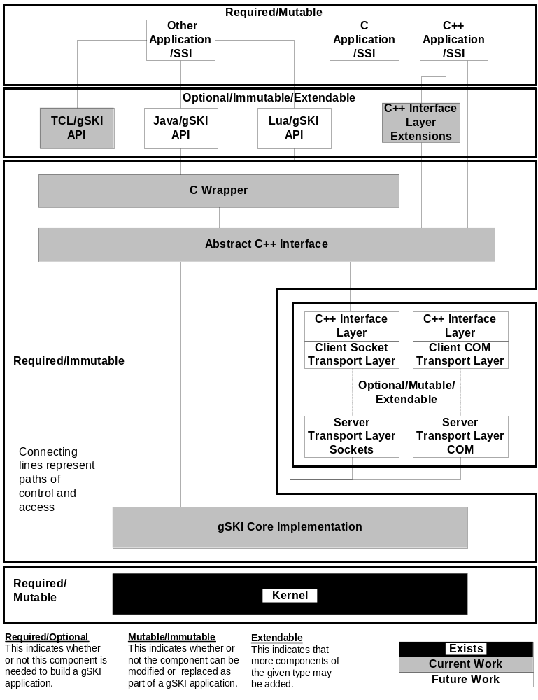
Figure 1: gSKI and Soar systems. gSKI is really an API and is implemented at several levels. The core implementation is the Abstract C++ Interface and its underlying implementation.

